Build instruction
Tension Hardware
We assembled the actuator base with the 2 bronze plates, the rear plate and the bottom plate, using 2 M6 of 25mm button head hex socket screws. Afterwards, the support plates for the actuator were adjusted on the bottom plate of the base. To achieve this, first we inserted 2 M5 of 70mm countersunk hex socket screws, then secured the plates with 2 M5 of 16mm countersunk hex socket screws. Then, we flipped it over and fastened the rear part of the base to the back of the actuator using 2 M6 of 20mm button head hex socket screws.
After this, we assembled the positioning plate by screwing the sample aligner base to the steel plate with 2 M4 of 5mm Phillips countersunk screws. Then, using 4 M6 of 16mm button head hex socket screws, we fastened it to the actuator positioner.
Now, for the motor: we placed the actuator coupling onto the motor, which comes with its M4 of 12mm Allen hex socket screws for tightening. Afterwards, we positioned the motor aligned with the threaded holes of the actuator and fastened it with 4 M4 of 15mm Allen hex socket screws.
We then coupled the steel sphere with a threaded hole to the load cell using an M6 of 16mm set screw (or a 6mm diameter steel rod threaded on both ends). The same was done to attach the jaw to the load cell. After that, the lower jaw was screwed to the bottom plate of the base using an M6 of 16mm set screw.
Finally, we replaced the screw on the adjustment jaws with 2 M6 of 25mm button head hex socket screws. A complete step-by-step assembly tutorial is available in https://youtu.be/UyuWO1eD-a8

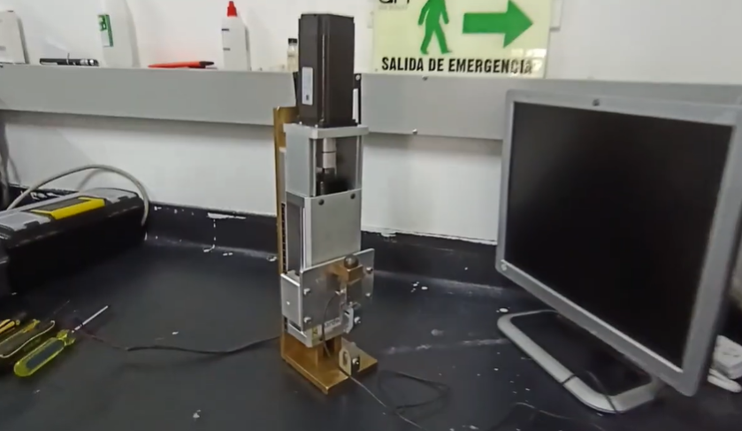
Figure 1: A frame for the step-by-step assembly tutorial of the Tension Hardware.

Optical Support
Before assembling everything, we putted 3 M6 nuts into the 3D printed support. These nuts were preheated to adhere better, and superglue was also used for a complete bond.
First, we used 2 M5 of 16 mm hexagon socket countersunk head screws to fasten the bottom plate of the support holder base to the rear plate. Next, we used 2 M5 of 20 mm hexagon socket countersunk head screws to fasten the top plate to the rear plate of the support holder base.
Now, to assemble the rail, we first mounted the top rail cover by fitting the 2 silver steel rods into the holes of the copper plate using 2 M6 of 16 mm hexagon socket set screws. After this, we inserted the 2 rail rods into the holes of the positioning piece. Then we assembled the adjustment cranks, which were made using 2 modified 3/8-inch aluminium rods, shaped to have a thick cylindrical head with a 1/4-inch bore and M6 threaded hole for a 20 mm screw to perform the adjustment to the rail, along with 2 other 1/4-inch rods threaded M6 at the ends, which were secured with 2 thick M6-threaded cylindrical heads. These rods serve as the crank adjustment levers.
For the clamping press of the holder base, we assembled another crank using a 3/8-inch aluminium rod 40 mm long. This rod was drilled and threaded to form an M8 screw with a thick cylindrical head, and a 1/4-inch bore, through which the crank handle is inserted. Like the others, this handle was made from a 1/4-inch aluminium rod threaded M6 at both ends and is secured with 2 thick M6-threaded cylindrical heads. Additionally, a truncated cone-shaped plug with M8 threading was designed to fit onto the end of the M8 screw, allowing better clamping of the base to the table. Afterwards, we proceeded to join the holder base with the already assembled rail, securing the rail rods to the top plate of the base using 2 M6 of 15 mm hexagon socket set screws.
Finally, we mounted the steel transverse shaft and secure it using a M6 of 25 mm knurled thumb screw, and we fixed the 3D-printed camera mount using a M6 of 20 mm Slotted cheese head screw. We also use one M6 nuts, which was fixed to the part to properly screw it onto the shaft. We did the same with a M6 of 30 mm Slotted cheese head screws and 2 M6 nuts. A complete step-by-step assembly tutorial is available in https://youtu.be/Ijc06AQWEIM
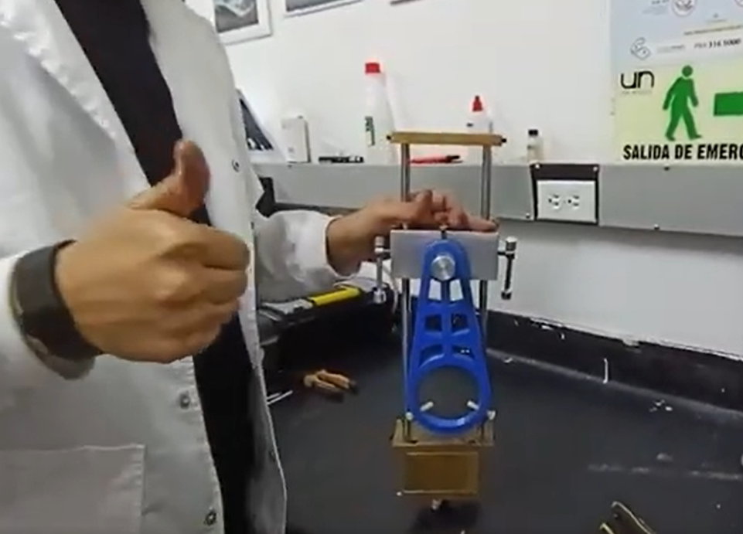
Figure 2: A frame for the step-by-step assembly tutorial of the Optical Support.

Optical system
The mesoscopic camera consists of a Maant XJ-1 2 camera, a TV050 monocular optical zoom with a W050 Barlow lens, a Wozniak iFixwa iL37 LED light ring, and a support ring for attaching the optical system to a Weifeng WT-3560 camera tripod. An exploded view of the setup is presented in Figure 3.
To assemble the mesoscopic camera, we first attached the support ring to the TV050 optical zoom by tightening it with the clamping screw that comes with the ring. Next, we joined the Maant XJ-1 2 camera and the zoom by screwing them together carefully, taking care not to dirty the camera sensor, until they were properly tightened. Now, to place the LED light ring, we must have to align the three adjustment screws with the threaded holes, so they match and then tightened them gradually, all at the same time. After that, we placed the W050 Barlow lens on the free end of the zoom, being careful not to dirty either side. Finally, we attached the optical system to the tripod by adjusting the coupling piece of the tripod to the support ring using the adjustment screw.
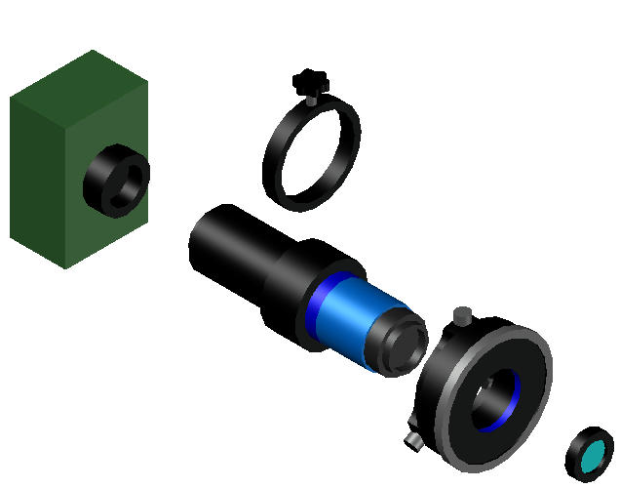
Figure 3: Exploded isometric view of the mesoscopic camera assembly.

Regarding the wiring, the camera's USB 3.2 port was used, connecting it to the corresponding port on the mini-PC using the USB 3.2 to USB-C cable along with the USB-C to USB 3.2 adapter. Additionally, the camera was plugged into a wall outlet using its power cable. Finally, we connected the LED light ring to the secondary USB port of the camara, but it can be connected either to the camera's secondary USB port or to one of the auxiliary ports on the mini-PC.
The microscope camera was assembled in 2 ways. One of them used the Maant XJ-1 2 camera, a TV150 monocular optical zoom with a W075 Barlow lens, a Wozniak iFixwa iL37 LED light ring, and a support ring for attaching the optical system to the fine positioning hardware and optical support. The other setup used the Maant XJ-1 2 camera, the TV150 monocular optical zoom, the LED light ring, the support ring, and additionally a C-mount to 23.2 adapter with a 30mm adapter ring, a 3W coaxial light, a half-reflection half-transmission lens with an RMS adapter, and a 5X planar objective lens featuring a numerical aperture of 0.12, a working distance of 23.6 mm, a lateral resolution of 2.8 μm, a depth of field of 42.9 μm, a focal length of 36 mm, and a field of view of 4.5 mm.
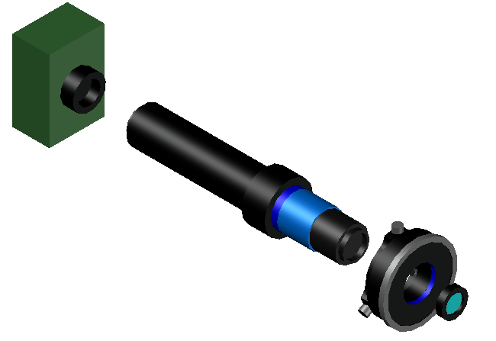
Figure 4: Exploded isometric view of the optical zoom and Barlow lens microscope camera assembly.
To assemble the TV150 optical zoom and W075 Barlow lens setup, the support ring of the fine positioning hardware and optical support was first attached to the optical zoom by tightening the 3 screws of the ring gradually and simultaneously, ensuring the correct alignment of the optical system. After this, we carried out the same process already described for the LED light ring: aligning the three adjustment screws with the threaded holes and tightening them gradually, all at the same time. Then, we placed the W075 Barlow lens by screwing it onto the end with the LED ring, being careful not to dirty either side. To finish assembling this microscope setup, we positioned the support ring in the coupling area of the fine adjustment and positioning hardware, and to guarantee stability and alignment, the screws were tightened in the same way as with the support ring and the LED light ring. Finally, and taking care not to dirty the camera sensor, we screwed the camera onto the zoom. See Figure 4 for an exploded 3D overview of the assembly.
Now, for the setup with the 5X objective lens, we carried out the same steps as in the previous setup, with the difference that the objective lens was used instead of the W075 Barlow lens. An exploded view of the setup is presented in Figure 5. So, to mount the objective lens, the M26 to C-mount adapter was first screwed onto the zoom, and then the C-mount to 23.2 mm adapter was attached. To connect the adapter already fixed on the zoom with the half-reflection half-transmission lens, the 30mm adapter ring was press-fitted, and then the half-reflection half-transmission lens was also press-fitted onto the adapter. To attach the LED light source to the lens, we used the side hole that comes with an adapter that fits the light source; the 8mm to 14mm adapter was used, since the width of the light lamp was 8mm. Finally, on the end of the half-reflection half-transmission lens with the RMS thread, we screwed on the 5X objective lens.
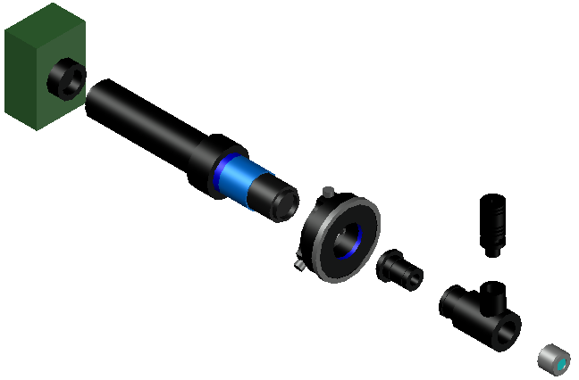
Figure 5: Exploded isometric view of the 5X objective lens microscope camera assembly.
As with the mesoscopic camera, regarding the wiring, the camera's USB 3.2 port was used, connecting it to the corresponding port on the mini-PC. The camera was plugged into a wall outlet using its power cable, as was the LED lamp. Finally, and as with the mesoscopic camera, the LED light ring can be connected either to the camera's secondary USB port, to one of the auxiliary ports on the mini-PC, we connected the LED light ring to the camera's secondary USB port.

Wiring
Regarding the system wiring, this was divided into 3 main environments: the wiring of the system dedicated to the collection and transmission of the load cell data, that of the motor control and synchronization system, and that of the image acquisition system.
Since the optical image acquisition system already has its own section where the method for wiring it to the mini-PC is explained, we move directly to the wiring instructions for the other 2 environments.
So, for the correct assembly of the motor control and synchronization system, we followed the wiring instructions for the T60 driver and the 57A3ED closed-loop stepper servomotor. First, the motor was wired to the driver following the colour code of the set of 4 wires associated with its coils: the red wire was connected to the A+ pin of the driver, the blue to A−, the green to B+, and the black to B−. Subsequently, the set of 6 wires belonging to the motor encoder was wired to the driver according to its respective colour code: the green wire to the EB+ pin, the yellow to EB−, the brown to EA+, the white to EA−, the red wire to Vcc, and the blue to GND. After successfully connecting the motor to the driver, had to wire the driver to the Drok 200570 variable-voltage power supply, configured at 24 volts; this was done by wiring the V+ pin of the driver to one of the V+ terminals of the power supply, and likewise the V− pin to a V− terminal. Finally, the signal pin section of the driver was wired to an Arduino UNO R3 with USB communication to the mini-PC, using a breadboard: the PUL+, DIR+, and ENA− pins were connected to pin 9 PWM of the Arduino, and the PUL−, DIR−, and ENA+ pins to the digital GND of the same Arduino. To a more graphical and didactic view, please refer to the figure 6, or the corresponding fritzing file.
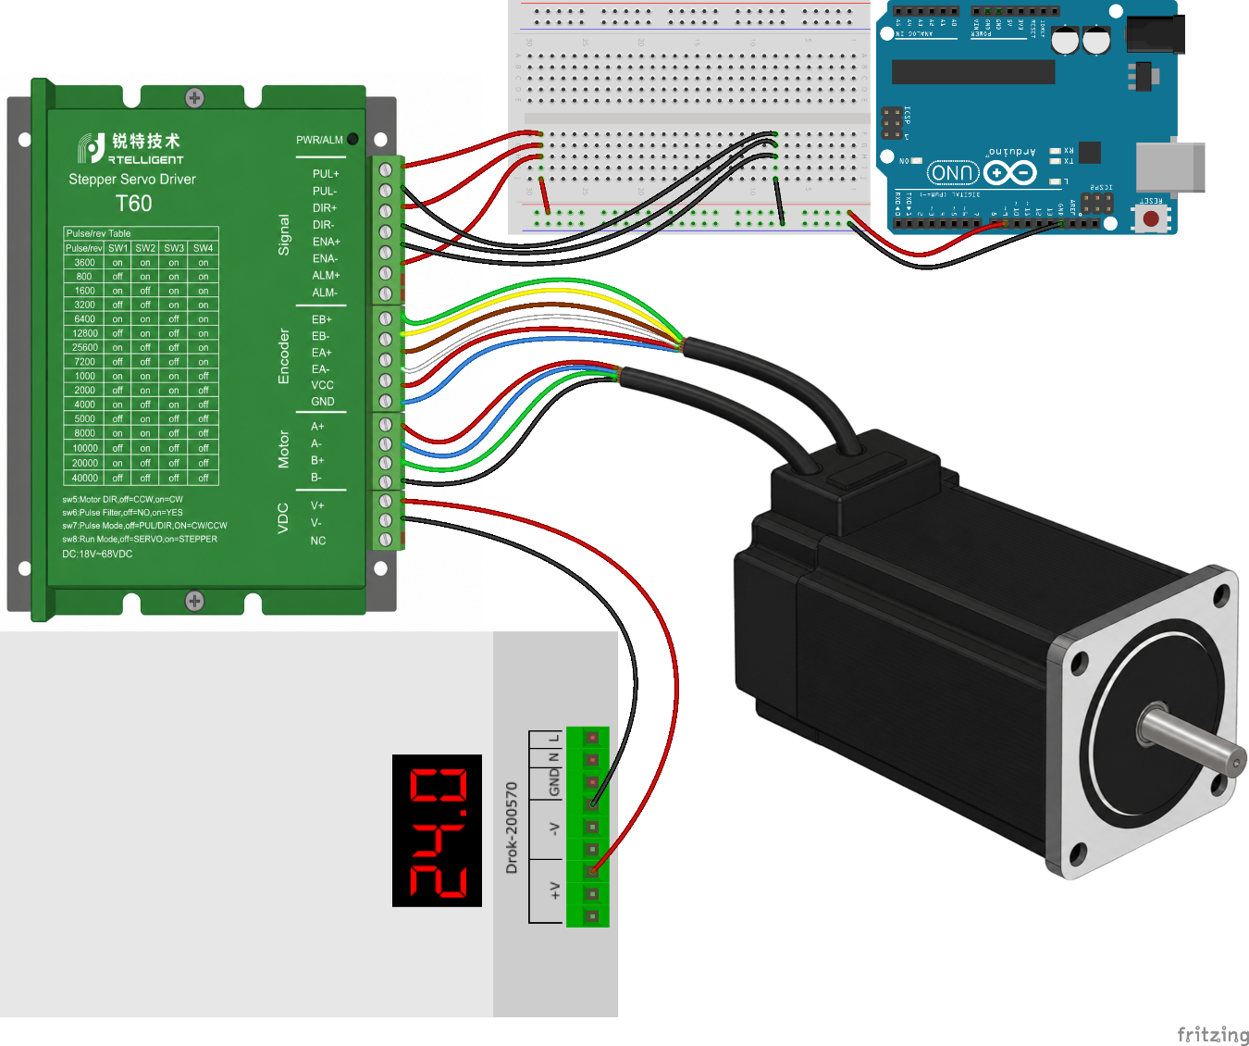Figure 6: Wiring's breadboard layout of the motor control and synchronization system.

Now, for the wiring of the load cell data collection and transmission system, 2 setups were used, one for the 50 kg cell and another for the 1 kg cell. In both setups, an Arduino Nano connected to the mini-PC via USB was used for data acquisition.
In the setup for the 50 kg S-type miniature load cell, a DYLY106 model with a 2.0 mV/V output was used together with a WXD-D70 weight transmitter amplifier with a sensitivity of 2.0 mV/V, configured for a 0–5 V output. These were connected following the colour code of the load cell, where the yellow wire was connected to the GNDD (shield) pin of the amplifier, the black wire to the GND pin, the red to the E+ pin, and the white and green signal wires to the S+ and S− pins; those two can be swapped depending on whether the cell is to be used for compression or tension. Then, the amplifier was wired to the Arduino and to the power supply, which is the same one used for the motor control and synchronization system. For the connections to the Arduino, the Vo pin of the amplifier was wired to the A0 pin of the Arduino, and the GND pin of the amplifier to the analogue GND pin of the Arduino. For the connection to the 24 V power supply, the 24V pin of the amplifier was wired to one of the V+ terminals of the power supply, and the GND pin of the amplifier to one of the V− terminals of the power supply. As in the assembly of the motor control and synchronization system, please refer to the figure 7, or the corresponding fritzing file, for a more graphical or didactic view.
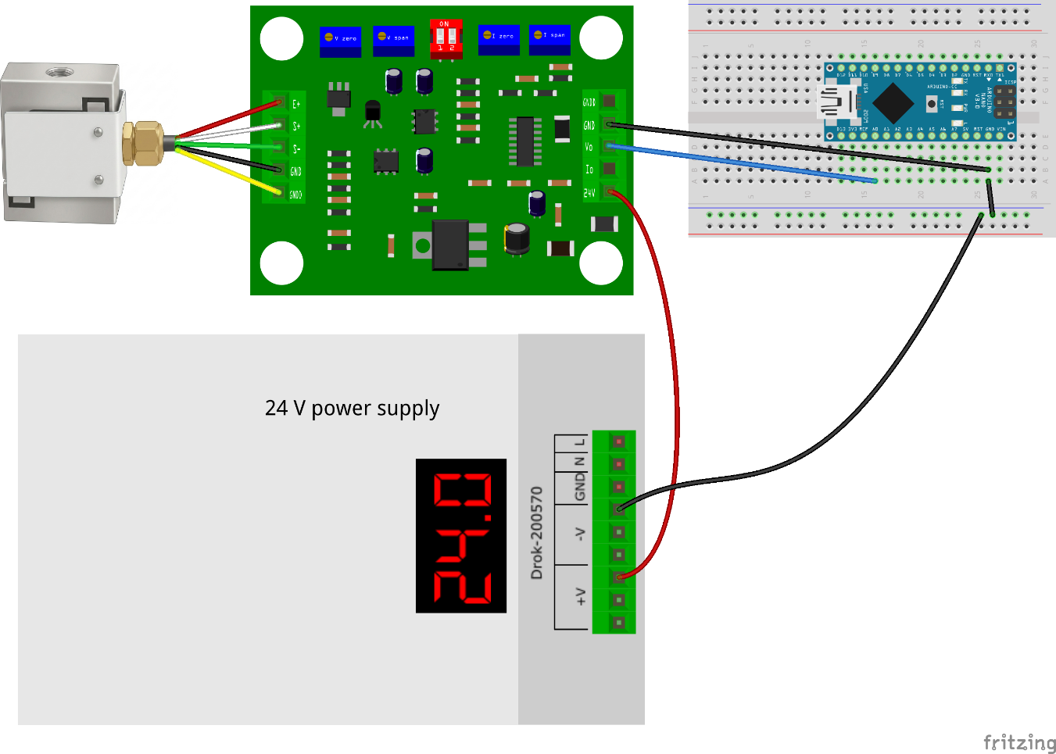Figure 7: Breadboard layout of the wiring for 50 kg load cell setup.

Since, for the 1 kg setup, a DYLY106 S-type miniature load cell was used but with a maximum capacity of 1 kg and a sensitivity of 1.0 mV/V, we had to use a load cell signal amplifier that accepts an input signal sensitivity ranging from 0.8 to 3.0 mV/V, with a 0–5 V output. Although the wiring for this setup is similar, the cell's amplifier delivered a output signal with very high fluctuation, so a stabilizer circuit was needed so that the Arduino could correctly read the amplifier's signal. Thus, for the connections between the load cell and the amplifier, the load cell's colour code was followed: the black wire of the cell was soldered to the E− pin of the amplifier, the red was soldered to the E+ pin, the green was soldered to the S− pin, and the white to the S+ pin. As with the 50 kg setup, the connection of the white and green wires is interchangeable depending on the mode to be used. Regarding the 24 V power supply, as with the 50 kg cell configuration, the same one from the motor control and synchronization system was used, where one wire was connected to a V+ terminal and another to a V− terminal of the power supply, and then soldered to the V+ and V− pins of the signal amplifier, respectively. Subsequently, 2 more wires were soldered to the O+ and O− pins of the amplifier, which are the pins responsible for the signal received by the Arduino. Finally, for the wiring of the amplifier to the Arduino, a stabilizer circuit based on an RC low-pass circuit was used, employing a 10 kΩ resistor, a 10 µF electrolytic capacitor, and a 100 nF ceramic capacitor, where the wire from the O+ pin was connected to the resistor, and this resistor to the A0 pin of the Arduino. Then the capacitors were wired in series, starting with the electrolytic one with its positive terminal to the A0 pin and its negative terminal toward the ceramic capacitor. After that, the ceramic capacitor was wired to the analogue GND pin of the Arduino, which was connected to the wire from the O− (GND) pin of the amplifier. For clearer and more understandable view of the wiring, please refer to the figure 8, or the corresponding fritzing file.
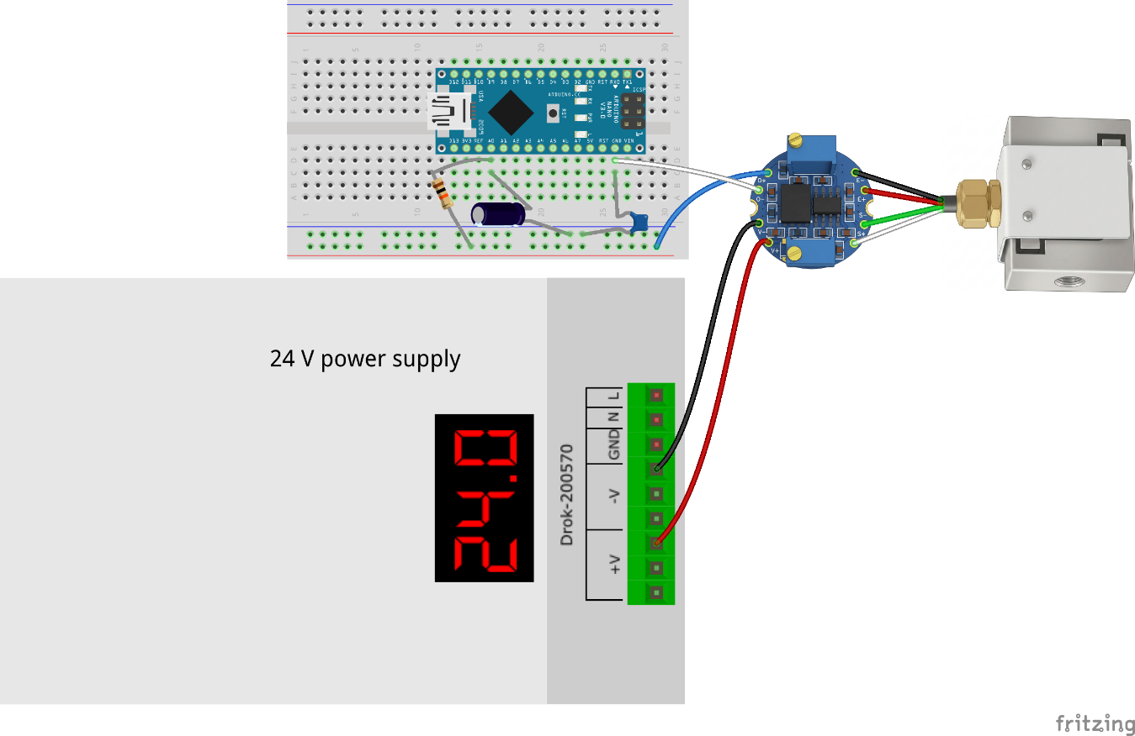 Figure 8: Breadboard layout of the wiring for 1 kg load cell setup.

